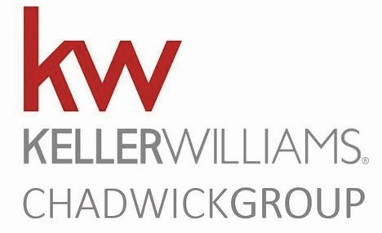A GUIDE TO SELLING YOUR HOME

Getting to Know You

What do you expect from the real estate company and agent you choose to market and sell your home?

1. Why are you moving?

2. When do you want (or have) to move?

3. How long have you lived in your present home?

4. Who else are you talking with about the sale of your home?

5. Have you thought about a price for your home?

6. How did you arrive at your price?

7. What are your major concerns about making a move?

8. What is the most important to you - Price Timing Convenience

9. What would it do to your plans if you decided not to sell?

10. Are you prepared to list your home today?
A GUIDE TO SELLING YOUR HOME

Preparing for success

Meeting the expectations of my customers is important to me, and working with a Realtor that works hard to sell your home for the most amount of money, in the least amount of time, with the least inconvenience to you is likely important to you. Is there anything else that I should know that will make our relationship a success?

Can you share your top 5 behaviors or actions that will help me either build or erode our relationship?

WIN

1.

2.

3.

4.

5.
LOSE

1.

2.

3.

4.

5.

What do you expect from me as your real estate consultant?

What do you feel I should expect from you as my customer?

